INTRODUCTION

The scenic beauty of Kachemak Bay is an Alaskan natural treasure. This Design Manual has been adopted in order to maintain and improve the overall quality of the built environment and the way it fits into this splendid natural setting.

As an area dependant on the visitor industry, the appearance and aesthetic quality of Homer takes on an economic importance. These design standards are intended to create and maintain a community that is visually attractive to both residents and visitors.

The built environment cannot equal the splendor of our natural setting, but we can strive to reflect and respect the good fortune we find here. The City of Homer Design Manual has been created to foster this goal.

Correctly applied, DESIGN REVIEW can be an effective mechanism of increased flexibility in the application of zoning regulations.

It allows for early discussion of a proposed project's design and can provide examples that demonstrate how projects can better fit their environment.

As a result of this increased dialogue and flexibility, new development will have an opportunity to enhance Homer's character more effectively than would be possible if zoning regulations alone were strictly applied.

Homer's Design Review Goals are:

- To encourage better design and site planning so that new development will compliment Homer's existing character as well as allow for diversity and creativity.
- Facilitate early and ongoing communication among property owners, neighborhoods and the City.
- Increase public awareness of design issues and options.
- Provide an objective basis for decisions which address the visual impact of the City's future growth.
- Ensure that the intent of development standards established by the 1999 City of Homer Comprehensive Plan Update are met.

Design Review in Homer will be considered at three broad levels.
It is evident from the Comprehensive Plan's design element that design consideration must entail far more than the appearance of individual buildings. Accordingly, this book will consider design at three broad levels under the titles Architecture, Site Design, and. Connections.

Architecture
The Architecture section addresses the more traditional aspects of design review including the details of a building's design, its relationship to surrounding structures, and how the design will be viewed from specific vantage points.

Site Design
The Site Design section deals with site amenities intended to enhance the visual character of the site invite outdoor activities and connect public rights-of-way to structures on private property.

Connections
The Connections section will focus on right-of-way development and how streets can be designed to connect other areas of the city, to compliment development on private property and to create a strong community image.

In each instance, these guidelines are intended to identify and respect important visual patterns in the built environment and relate these to Homer's natural amenities.

APPLICABILITY
The standards in this manual apply to public and private development within all sections of the City as identified in Homer City Code, Title 21. The extent of design review varies according to the location and type of development. Within this manual applicability is further defined and is summarized below:
Site Plan Review – CBD; GBD; SGCOL
Architecture - CBD; GBD; SGCOL
Site Design:
On-site walkways – CBD; GBD; SGCOL
Outdoor common areas – CBD; GBD; SGCOL
Commercial streetscape – CBD; GBD; SGCOL
Landscaping and screening- CBD; GBD; SGCOL
Fences - CBD; GBD
Parking – CBD; GBD; SGCOL
Outdoor lighting – CBD; RR; UR; RO; GBD; SGCOL and the portion of GC1 lying south of Beluga Lake
Outdoor furnishing – CBD; GBD; MC; MI; GC1 adjacent to Ocean Drive

The reader should be familiar with all portions of this document before proceeding with any building or site improvements. Finally, the reader should be aware that the graphics contained in this document were added to assist in defining the standards herein. They are not meant to be viewed as literal solutions or absolute design directives.

DESIGN REVIEW OPTIONS

This Design Review Manual represents a statement of policies which shall be observed for building and site design in the City of Homer. Design policies include both general requirements and specific performance standards. General requirements include all bold and underlined text in the document. - Specific standards include the more detailed text which immediately follows general requirements.

Homer Advisory Planning Commission (Commission) Approval. The City of Homer encourages a creative approach to design by providing a flexible review standard.

The Commission is authorized to waive specific Design Manual requirements if it finds that (a) an alternative design represents an equivalent or superior design solution to what would otherwise be achieved by rigidly applying specific requirements, and (b) the alternative design meets the intent of the general requirement.

Design Review may occur at any point in the permitting process, i.e. before, during, or after a Conditional Use public hearing. It shall require a separate public notice if not performed at the same time as a Conditional Use public hearing.

Appeals to a Design Review decision by the Commission may be filed in accordance with HCC 21.68 Appeals.

To best determine the general requirement's intent, the Commission shall consider the specific requirements as appropriate examples of compliance.

Quality design is more important than strict conformance.

DESIGN REVIEW APPLICATION
REQUIREMENTS

Application for design review shall be submitted in such detail as to allow the review of the specific project on the merits of this document and other applicable City codes. It is not the desire of the City of Homer to burden the applicant with unnecessary and costly application requirements to gain approval of their project. To assure that design review is performed in an expeditious and cost effective manner, projects may be reviewed in one complete application or may be reviewed by category. To be considered complete, the following information must be submitted for each category of requested design review.

Applicable Areas and Uses:
Within Areas Zoned Central Business District; Gateway Business District
All non-residential uses and uses with more than 12 residential units.

Within Areas Zoned Scenic Gateway Overlay District:
All uses except single family dwellings and duplexes.

- Site Plan Review

  - Site and Access Plan. A site plan, drawn to scale no smaller than one inch equals 20 feet showing location and size of all structures, buffer areas, yards, open spaces, common areas or plazas, walkways, vehicle areas, and right-of-way access.

  - Existing Vegetation Plan. A significant vegetation plan which identifies the type, and general location of existing significant vegetation within the area to be developed and within 5 feet of all setback lines.

  - Landscape Plan. A landscape plan showing the species, and general location of all significant native vegetation to be retained, and new vegetation.

  - Site Section Drawings. Section drawings which illustrate existing and proposed grades in specified areas of concern as identified by the staff, or on slopes greater than 15%. Alternatively, an accurate topographic map delineating contours, existing and proposed, at no greater than five-foot intervals and which locates existing streams, wetlands and other natural features may be submitted.

  - Grading & Drainage Plan. An accurate grading and drainage plan which indicates all cuts, fills and required areas of disturbance necessary to construct all retaining walls and structures.

  - Utilities Plan. A utilities plan showing location of utilities in relation to landscape and buffer areas (utility plan must be consistent with proposed areas of non-disturbance).

  - Paving Materials. Description of all pedestrian and vehicular paving materials. Descriptions must specify type, color and/or texture.

  - Elevations from primary public access road.

3. Architectural Design Review

- Elevation Drawings. Complete elevation drawings of all buildings showing dimensions, trim details, and proposed materials including roofing, siding, and windows.

- Sign Plan. A master sign plan showing the location of all signage consistent with HCC 21.60.

- Architectural Lighting Details. Details on all lighting proposals which affect architectural detailing (e.g., indirect lighting), or which are for architectural enhancement.

- Screening details. Details on how all mechanical and utility equipment will be screened.

4. Color and Material Review

- Color Palette. A color palette of the building's exterior including roof, siding and trim.

- Fencing Details. Color, type and appearance of all fencing and screening materials.

5. Outdoor Lighting & Accessories Review

- Light Fixture Details. The type, appearance, location, height, and area of illumination for all outdoor light fixtures.

- Accessory Details. The type, appearance, and location of all outdoor furniture, trash receptacles, and accessories.

ARCHITECTURE

GENERAL REGULATIONS
A sense of place cannot be achieved with a single building. It is the cumulative effect of each building and their relationship to surrounding buildings that creates rhythm and pattern and defines scale in the city's streetscapes. The following design standards will help to achieve this:

Applicable Areas and Uses:
Within Areas Zoned Central Business District and the Gateway Business District:
All non-residential uses and uses with more than 12 residential units.
Within areas zoned Scenic Gateway Overlay District:
All uses except single family residential and duplexes.

The building and its setting:

Buildings shall be designed to reflect the natural conditions of the site and shall include design elements which visually "anchor" the building to the site:

- Incorporate building design elements into landscaped areas. Without some form of transition between the ground and the building wall, structures can appear to be unrelated to, rather than part of, the site. This is especially true of stand-alone buildings in large open spaces. By extending secondary structural elements from the building out into the site, a transition between the ground and the building wall can be achieved. Low walls, stairs, walkways, or small plazas, for example, can help anchor and transition the building to the site.

- Determine allowable building height. Refer to zoning code for allowed heights in specific zones.

- In the Scenic Gateway Overlay District development, such as fences, buildings and landscaping, that blocks over 50% of the existing scenic vistas or contains development visible over 50% of the street frontage is strongly discouraged.

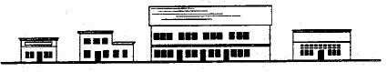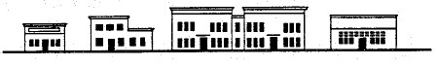
UNACCEPTABLE ACCEPTABLE
Although this building is large, it includes projections which are similar in height and scale to adjacent structures
This large single mass building is out of scale with adjacent structures.

4. Respect natural topography. Buildings shall be designed to fit natural slopes rather than forcing the slope to fit a particular building design. Buildings shall be designed with both up-hill and downhill floor plans if the site involves significant slopes. Minimize cut & fill by developing designs which compliment and take advantage of natural topography. Sloped lots may require terraced parking lots and multi-level buildings designed to follow the slope. Sloped lots can be particularly well-suited for lower level parking garages.

Parking lot follows natural terrain

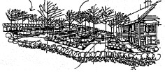
Parking lot designs should maintain natural topography as closely as possible.

Walkway and steps provided from parking lot to building

Natural Grade
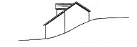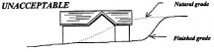
Finished Grade

ACCEPTABLE UNACCEPTABLE

Structure should be designed to fit natural slopes.
Avoid significant regrades by selecting designs which fit natural topography.

5. In the Scenic Gateway Overlay District changes to slopes can be made to maintain views.

Building Lighting:

Lighting may be used to accent a building but shall not be used to denote a corporate or commercial image except on allowed signage. Lighting may be directed to a building but should generally not emanate from a building.

- Avoid back-lit panels and awnings. Translucent panels and awnings illuminated from behind are prohibited. This shall not exclude soft light being emitted from windows.

- Keep light source hidden from public view. Except for decorator lights with frosted lenses or which use clear bulbs (e.g., candelabra bulbs) light sources shall be concealed behind soffits, within recessed containers, behind shrubbery, etc.

- Avoid bright lighting on outdoor surfaces of buildings. Outdoor building lighting is limited to low levels except that more intense lighting is allowed at building entrances.

- Avoid colored lighting on buildings. Colored lighting is limited to temporary holiday lighting only.

- Apply utility lighting sparingly. Utility light fixtures which have an industrial or utilitarian appearance may be used for security lighting on buildings, but shall not be used in areas of concentrated lighting (e.g., service station canopies) unless the fixtures are not seen from public rights-of way.

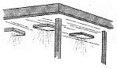
High intensity light sources may not be visible to the public. Fixture designs of an industrial or utility appearance shall be avoided.

6. Lighted accents, canopies, color bars, stripes or areas. Buildings with lighted accent areas are using this device to call attention to the business. These areas should be used sparingly and are counted as part of the allowed sign area.

Prominent Facades:

Prominent facades include all building facades visible from waterways, arterials, and activity centers, and also facades which face the road(s) providing primary access to the building's site. Prominent facades may not be sterile wall planes void of architectural interest. They shall be detailed with added relief, shadow lines, and visual depth unless screened with landscaping.

- Apply all design criteria to prominent facades. Prominent facades, whether the front, side or rear of the building, are subject to full design review and shall comply with all design criteria stated herein unless full on-site screening by vegetation can be achieved within 3 years.

Building Scale and Mass:

One of the most prominent characteristics of a building's design is it's scale and massing. The scale of a building determines its size in relation to surrounding buildings; the massing of a building gives it interest and character. Modern building trends emphasize large-scale designs with no thought toward massing. This imbalance between size and visual character has resulted in visually obtrusive development which is out of character with surrounding structures of a smaller scale. Large retail boxes epitomize this trend and are considered incompatible with Homer's small town characteristics.

1. Avoid long, low wall planes. Prominent facades shall have no wall plane wider than 2.5 times the height of the wall plane.

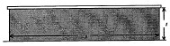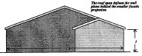
H
W
H
W

UNACCEPTABLE UNACCEPTABLE

Height/Width proportions apply
with or without gable

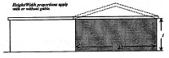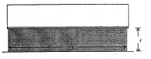

H
W
W
H

ACCEPTABLE UNACCEPTABLE

- Provide substantial shifts in walls and roof surfaces. Wall and roof surfaces shall be broken down into smaller planes using substantial shifts in building footprints that result in substantial shifts in roof lines as follows:

- Horizontal shift - No portion of a prominent facade may exceed 60 feet in length without a shift in the building footprint measuring 1/10 of the facade length. This shift may be broken down into smaller shifts of at least 4 feet each. Horizontal shifts, when required, shall be reflected by a shift or alteration in the roof design. To assure that footprint shifts are evenly distributed across the building facade, shifted wall planes shall have a width proportion of between 1-to-1 and 3-to-1 the width of adjacent wall planes on the same facade.

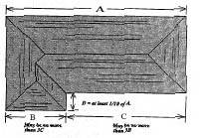
D= At least 1/10 of A
A
B
C
May be no more
than 3C
May be no more
3B
Horizontal shifts required if "A" exceeds 60 feet in length

- Vertical shift - No single run of ridge, cornice, or fascia (excluding eave overhang) shall exceed 60 feet without a minimum 4-foot transition in height.

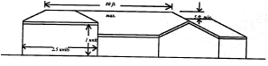
80’ MAX
1 UNIT
2.5 UNITS

4’ MIN

- Provide visual terminus to tops of buildings. In order to avoid a truncated look at the top of the building, all structures shall have a visual "cap”. This may include either a pitched roof or a flat roof. Pitched roofs shall have the appearance of true hips and gables with a defined ridge where opposing roof planes meet. Roof designs must conform to one of the following options:

- Lower pitched roofs with extended eaves - A lower pitch roof with a 4/12 pitch or less is allowed provided eaves extend at least 2 feet beyond exterior building walls. A minimum of a 4/12 pitch is preferred.

- Steep pitch hip or gable roof form - conforming to the following roof pitch requirements:
  - Minimum pitch - 4/12 in all areas:
  - Maximum pitch - 12/12 in all areas.
Exceptions: Steeples, bell towers and other ancillary structures.

- False pitch roof with appearance of true hip or gable - Single story and multiple story buildings may, have a flat roof with a false pitch if :
- The roof appears to be a true hip or gable from all public vantage points, and
- There are extending wings on each corner of the building which allow for a true hip or gable to extend out from the false hip or gable (this will avoid a mansard roof appearance).
- These roofs shall have a minimum 4/12 pitch, with eaves extending at least 2’ beyond exterior walls.

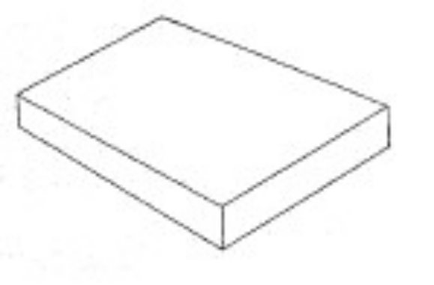
UNACCEPTABLE - A simple box-like structure.

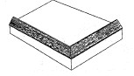
UNACCEPTABLE - The box structure with simulated mansard.

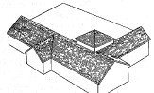
ACCEPTABLE - Notice how the gable ending beyond the corner of this box structure provides the appearance of a true gable from the public's vantage point.

- Avoid unusual or atypical roof forms on all structures. A-frame, modified A-frame, curvilinear, domed, and mansard style roofs and other unusual or atypical roof forms are discouraged. Multiple gables over a single-mass structure forming a "saw-tooth" design are also discouraged. These discouraged roof forms may only be considered through Commission review.
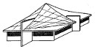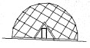
Curvilinear Geodesic Dome

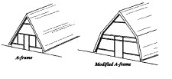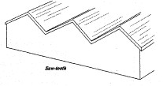
A-FRAME
MODIFIED A-FRAME
SAW-TOOTH

Examples of discouraged roof forms. Mansard roof forms are also discouraged.

- Limit roof areas in the same plane. The total roof area in a single plane shall not exceed 5000 square feet.

- Reflect mass and scale of adjacent structures. Structures shall reflect the mass and scale of adjacent structures. If a larger structure is built next to a smaller structure, it must include projections in the facade which approximate the smaller structure's massing.

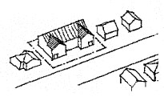
The projections in the facade of this larger building appropriately reflect the scale and spacing of the adjacent structures

- In the Scenic Gateway Overlay District- In addition to the above, building placement and scale will be set to foster a village type of feel. Several buildings or the use of modulation and design elements that give the appearance of smaller street frontages are favored over single building masses with large monolithic faces visible along street frontages.

Parking Garages:

The following requirements are intended to soften the visual impacts of parking garages as seen from the street face.

- Recess vehicle entries in main facade. Garage doors and open vehicle entries must be recessed at least 6 feet from the front facade plane.

- Screen parking garage facade. Parking garage facades which are visible from the street shall conform to one or a combination of the following options:

  - A landscaped screen. Screening may be trees, shrubs or wall clinging plantings on a trellis.

  - Store fronts. The parking garage may be faced with storefronts or display-windows.

  - Simulated storefront. The openings of the garage may be designed to reflect or simulate the window pattern and material choice of the primary structure on the site. The door and window fenestration requirements on this page should be used as a guide.

- Acquire Commission approval for all parking garages over 1 story or which enclose 20 cars or more. In making its determination of compliance, the Commission shall consider the design criteria under 1 & 2 directly above, and may also determine how much screening or architectural embellishment is required based upon projected lines of sight from the pedestrian's perspective.

Window and Door Fenestration:

The primary purpose of windows to the interior portion of a building is to let in light and air. To the outside of a building, windows can make an architectural statement. The challenge to the architect is to make sure that both objectives are met. Windows placed primarily to serve interior functions may appear to have been haphazardly placed on the outside of the building or may be completely lacking due to a reliance on mechanical systems for light and air. This shall be avoided. Windows can and should serve as a pleasing focal point in a building's design or emphasize a shift in a wall or roof plane. Windows should relate to, align with, or complement exterior design features of the building.

- Maintain balance in the placement of windows. To the extent possible, multiple windows on a single wall plane should be regularly spaced and aligned with other windows and doors on the same wall plane. Single or grouped windows on a wall plane should relate to other architectural features such as roof forms, doors, or facade projections.

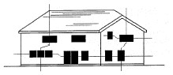
The scattered and haphazard arrangement of windows on this facade result in poor balance in the overall building design.
AVOID

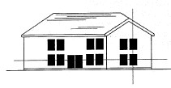
The careful alignment of windows provides visual balance to this facade. Notice that it is not always necessary to center windows on a wall plane. Usually, however, non-centered windows look better below a hip than below a gable

PREFERRED

- Conform to solid/void ratio requirements. Generally, windows and doors shall constitute a minimum of 25 - 30 percent of prominent facade wall planes. In situations where this is not practical, emphasis shall be placed on the building's form and texture. The following type of options may, in limited applications, be acceptable alternatives:

- Vertical and/or horizontal shifts in the facade combined with roof forms which accentuate facade variations.
- Variations in texture.
- Variations in exterior lighting.
- Vegetative screening.

- Reflective glass is discouraged. The use of reflective glass shall generally not be allowed but may be considered by the Commission in limited applications.

Siding and Trim:

Traditional building materials such as brick, stone or wood reflect human handicraft and provide texture to building exteriors. Materials for new construction and remodeling should convey similar visual qualities.

- Use materials which simulate quality traditional building materials. Finish materials must individually be characterized by texture, grain, or color variation. Individual components shall be small enough so that their collective application provides interest and texture to building facades and reflects human handicraft. Non-traditional materials shall be used sparingly unless they can be shown to have similar visual qualities of traditional materials or contribute to overall design character.

- Discouraged siding materials: The following materials must receive Commission approval. Creatively applied small sections of these materials may add architectural interest, but their use is discouraged as the predominant siding material.
- Corrugated or ribbed metal panels
- Sheet siding (e.g., T 1 -11)
- Concrete panels
- Tile
- Smooth Concrete Blocks
- Vertically ribbed or vertically grooved material
- Smooth or Flat metal panels

Miscellaneous Architectural Devices:

Building design should be executed in a straightforward manner. Tack-on devices may not be used to mitigate poor design or to promote a particular theme. If a particular style or theme is desired, it should be reflected in the building's form and general detailing.

- Architecturally integrated artwork is encouraged. Artisans are encouraged to create art and sculpture which compliment building architecture and the community.

- Avoid Architectural Gimmicks and fads. Types of gimmickry to be avoided include, but are not limited to, the following:

  - Tenant-specific motifs - Detailing or color used to promote a particular theme or to identify a specific tenant should be avoided. Signage shall be used for this purpose.

  - Neon Outlining - Architectural features shall not be outlined in neon, linear lights, or tube-type lights. This includes exposed and concealed lights.

  - Back-lit Awnings - Awnings may not be backlit or otherwise illuminated from behind unless the awning fabric is completely opaque so that it blacks out all light.

  - Non-functional Awnings - Awnings shall be limited to traditional locations over windows walkways, and entrances or over other architectural features where weather protection is needed. Awnings must be applied to walls or posts and may not be applied to existing projections over walkways or windows.

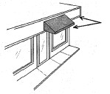
Avoid layering awnings over existing projections

- Maintain consistency in awning design. Multiple awning designs are not permitted on a single building.

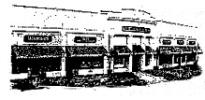
These awnings are consistent in design. Limiting their location to individual doors and windows assures that they do not overpower the building facade.

- Avoid awnings which obscure or dominate the building design. Awnings, canopies and marquees may not obscure architectural details of the facade and may not be the prominent design element of the building. They must appear as a secondary and complimentary element of the building design.

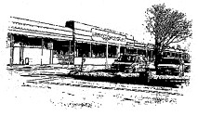
This continuous awning overpowers the building design and hides the original parapet or cornice detail.

Roofing Materials:

Views of roofs from the ground and from higher elevations play an important role in the architecture of the city. Roofing materials shall be selected according to the following criteria.

- Use roof materials which provide texture and shadow lines.

- Avoid bright-colored, reflective or unsightly roofing materials. The following roofing materials are discouraged and may only be considered by the Commission in unusual cases:
  - Gravel.
  - Untreated aluminum or metal (copper may be used).
  - Reflective materials (including aluminized hot-mopped roofs, white or light gray metals which have a metallic appearance in bright sun).
  - Brightly colored, highly visible roofing materials.
  - Red bar-tiles common to Spanish architecture
  - Urethane foam, painted and unpainted

Color:

Color is an important and dominant aspect of building design. When selecting colors, consider carefully the different materials and levels of detail that color can emphasize. The field or base color is one of the most dominating features of the building; trim colors are used on the building's secondary features, while accent colors can emphasize the finer, more characteristic elements of the building's design. Typically, no more than three colors should be used on one building, but additional colors may be considered if they are a close shade of one of the other three colors.

- Keep field colors subdued. Field or base colors (the main color of the exterior walls) are limited to the more subtle earth tone colors. White, soft sands, grays, light pastels, and deep rich clay colors are appropriate field colors.

- Limit bold or bright trim colors. Trim colors (fascia, cornice, window & door trim, kick panels, etc) may contrast or compliment the field color. Using a lighter or darker shade of the field color is always an appropriate trim color as is white.

- Finer details may be accented with brighter colors. Accent colors can generally be brighter than field or trim colors. Accent colors should be used with restraint. Appropriate areas for accent colors are those details that might otherwise go unnoticed such as moldings or molding indentations, medallions, and shadow lines of window and door frames. Doors are also an appropriate location for accent colors.

Hierarchy in Building Design:

Visual interest in the urban-scape can be achieved through a hierarchical approach to design. For example, strategically located structures, architectural elements or site amenities designed as focal points create a visual "draw" and suggest a point of activity. These serve also as a reference point for all subordinate structures. This concept is particularly applicable to large parcels with multiple structures. Multiple "carbon-copy" buildings provide no visual hub and shall be avoided.

- Design primary structure as a focal point. Primary structures are those which serve as a visual draw to a site. Primary structures shall be included on all commercial sites with more than one building, on commercial sites with a one or more multiple tenant buildings. Primary structures shall be designed as follows:

  - Primary structures shall be the focal point of development.

  - To assure a more stately appearance, primary structures are encouraged to have two levels and may include either commercial or residential space on the second level. The second level may be within habitable roof space. This is encouraged to provide interest to the building's roof form.

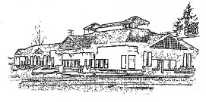
Even as a stand-alone building, hierarchy is evident in this design, making it appropriate as either a multiple-tenant building or as a primary structure on a multiple-building site.

  - Primary structures shall include a prominent entrance. The entrance may be defined by a projecting porch or portico or a clearly defined doorway designed as a focal point, in the facade design.

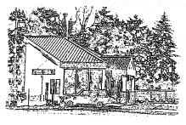
This more simple structure design, would be appropriate as a secondary building in conjunction with the primary building design above.

- Include area for outdoor leisure for Primary Structure. Primary structures shall incorporate either a prominent portico or plaza which is visible to the public and useable to customers or clients. Its size shall be at least 10% of the main level interior floor area. It must be incorporated into the building design. (This may or may not be the prominent entrance described above and may be applied toward requirement for a commercial common area described on page 20).

- Integrate secondary structures as support buildings. Secondary structures may be much simpler in design and still provide interest to the site plan or streetscape. Architectural interest is of less importance with secondary structures but they must meet all other design criteria for commercial buildings.
- Incorporate multiple tenant spaces into hierarchy of building design. Required facade and height variation will provide some degree of hierarchy in a building's design. Where possible, facade and height variation should reflect the location of individual tenant spaces.

- Provide consistent architectural interest to all prominent facades. All building facades prominently visible to public rights-of-way shall meet the following facade requirements.

  - Prominent facades shall not be blank walls.

  - Prominent facades shall reflect the same design and detailing which typify the building's front including roof design, window proportion, facade variation, and building materials.

  - Prominent facades may not be concealed behind high walls or privacy fences. Lower fences and walls not exceeding 3 feet in height are acceptable.

- Provide a common architectural treatment to all buildings on the same parcel or which are part of the same development. In order to provide an overall pleasing development, all buildings shall employ a complimentary architectural style and finish.

SITE DESIGN

Applicable Areas and Uses:
Within Areas Zoned Central Business District; Gateway Business District:
All non-residential uses and uses with more than 12 residential units.

Within Areas Zoned Scenic Gateway Corridor Overlay District:
All uses except single family dwellings and duplexes.

ON-SITE WALKWAYS

Primary Walkways:

Primary walkways are intended to link a building's main entrance to the public right-of-way and to facilitate and enhance the pedestrian environment.

- Link commercial buildings and the public right-of-way with primary walkways. Commercial buildings must be served by primary walkways which directly link the building's main entrance to the public right-of-way.
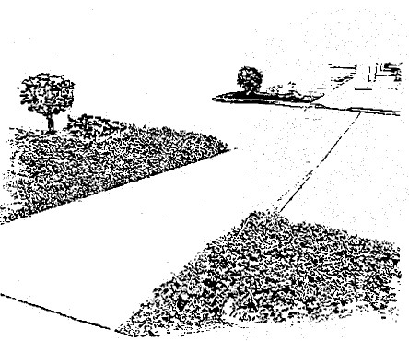

- Assure that primary walkway width is proportionate to scale of project. Primary walkways must be a minimum of 5 feet on small-scale projects; wider walkways may be required for larger scaled projects.

- Differentiate walkway surface. Walkways must be visually distinct from parking lot and driveway surfaces and may include textured or colored materials. Paint or striping will not suffice to meet this requirement. Walkways must be functionally separate from parking lots and driveways except where they cross driveways.

- Accent walkway with significant landscaping. One side of the primary walkway must be landscaped except where it crosses a driveway. The width of the landscaping shall be sufficient to maintain a proper planting environment. Planting strips must have an average width of 3 feet. Wider planting strips may be required for larger scaled projects.
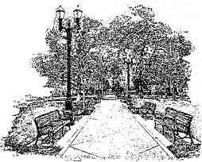

- Accent walkway with lighting and seating areas. Walkways longer than 100 feet must include lighting and seating as per lighting standards on page 30 and outdoor furniture standards on page 32.

- Identify historic events or structures. Plaques, signs or art work with applicable information about historic events or structures associated with the site are encouraged.

In addition to the above, development in the Scenic Gateway Overlay District will also include:

- Pedestrian circulation systems will be incorporated into the site design to assure that pedestrians can travel safely year-round and easily on the site and to adjacent public pedestrian ways.

- Major buildings and on-site open spaces will be connected by pedestrian ways.

- Non-motorized trails parallel to the Sterling Highway are considered normal frontage improvements for new developments. They should be consistent with the Homer Non-Motorized Trails and Transportation Plan and will be developed in cooperation with Alaska DOT, Kenai Peninsula Borough, the City of Homer and private property owners.

Secondary Walkways:

All commercial and multi-family parcels shall include an on-site pedestrian system that provides pedestrian movement between buildings without depending on parking lots for this purpose.

- Link each building with walkways. All buildings designed for residential occupancy or business access shall be linked to each other by a secondary walkway system. Public sidewalks may be considered part of the walkway system if they provide convenient movement between structures.
- Assure adequate walkway width. Secondary walkways must be wide enough for their intended purpose.

- Differentiate walkway surface. Walkways must be visually distinct from the parking lot and driveway surfaces. Where walkways are flush with driveways or parking lot surfaces, textured or colored materials can provide visual distinction. Paint or striping will not suffice to meet this requirement.

- Avoid walkways which cross parking stalls. Walkways may not be used for parking stalls. However, the ramp or loading area of a handicap-stall may be part of the walkway, subject to ADA conformance.

Secondary walkways connect
each building and are distinct
from parking lot surfaces

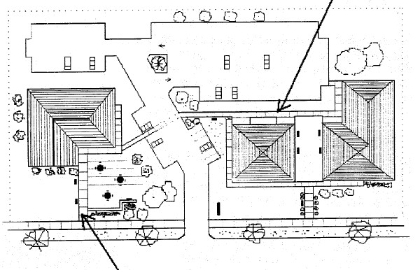
Primary walkway connects building’s main entrance with the public sidewalk. Notice how the outdoor plaza provides a visual focus to the site while enhancing the pedestrian environment.

OUTDOOR COMMON AREAS

A common area is a designed outdoor space which encourages outdoor activities and leisure in outdoor spaces associated with commercial development. Required common areas must be provided on-site, but may be enlarged and extended into city rights-of-way to connect with the sidewalk, subject to City of Homer approval.
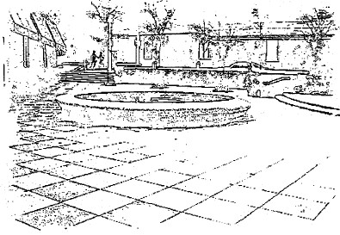

- Provide common area of a size proportionate to development. Commercial development greater than 5000 square feet in floor area shall include common areas equal to 5% of the gross floor area of the building to which they apply, excluding garages, warehouses, and similar support structures.

- Choose type of common area best suited to development. Common areas must include trash receptacles and casual seating and/or tables. Common areas must be one of (or a combination of) the following:

  - Balcony. terrace or covered colonnade - providing a minimum walking width of 8 feet and which also incorporates seating areas.

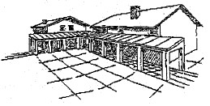

  - Plaza - with colored or textured pavement surface, e.g., brick, stone, exposed aggregate concrete or colored and textured concrete. To provide pattern and enhance the texture of the pavement, concrete surfaces shall be scored or otherwise divided into smaller sections.

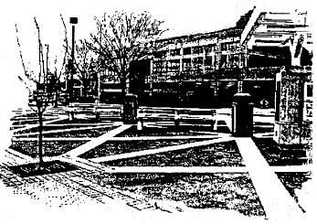

  - Pocket park - developed between or in front of buildings which include landscaped areas of grass, trees, shrubbery and flowers, combined with limited paths and pavement areas for casual tables and/or seats.

  - Scenic View Area - consistent with these design standards. Viewing platforms intended for public access shall be identified with signage located at the edge of the public right-of-way.

  - Off site common areas - For structures with less than 10,000 square feet of floor area, any of the above common areas which are within 250 feet of the subject site and are at least as large as the required common area for the subject site meet common area requirements and do not have to be repeated. This does not imply that the off site common area must be accessible for the subject site's use. It merely develops an appropriate density for outdoor common areas in a given district.

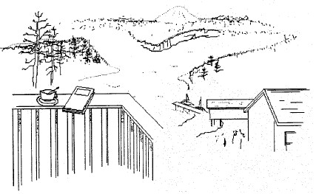

- Locate common areas in view corridors. Where view corridors occur on a site, common areas shall be located within the view corridor. Use care in the selection of landscape plantings so as to preserve views.
- Provide direct access to common areas with pedestrian walkways. Common areas (or outdoor stairs leading to common areas) shall be easily accessible to customers from the public right-of-way by either primary or secondary walkways.

- Provide outdoor seating where people want to sit. Pedestrian seating is encouraged in locations which allow enjoyment of sun and protection from wind and rain. Locate seating so that users can observe the activities of the street or enjoy a scenic view.

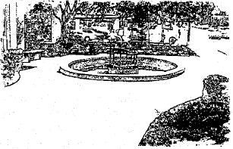

- Consider allowed activities in common areas. To assure full use and benefit of common areas to the property owner, the following activities are allowed in common areas:

- Vendor carts - limited to one portable handcart per 500 square feet of common area, up to a maximum of 4 carts, provided such carts do not impede pedestrian flow. Carts shall be on private paved common area, subject to owner approval. Carts must be portable and be stored away after hours.

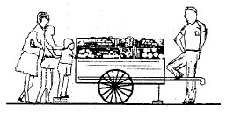

Temporary art displays - allowed in private common areas, subject to owner approval.

c. Outdoor sales - (e.g., farmers market) allowed one day per week.

d. Outdoor dining -- Common areas used for outdoor dining may add up to one seat per 20 square feet of common area without any additional parking being required. Such seating may not impede pedestrian flow.

COMMERCIAL STREETSCAPE

To enhance the visual quality and the pedestrian environment of commercial streets and activity centers, an increased emphasis should be placed on landscaping, pedestrian walkways and architecture. Parking lots and service areas should be visually diminished by keeping them to the side or rear of the buildings.

- Locate structure near front setback line. At least 50 percent of the primary structure's front facade shall be placed near the front setback line. The remaining portion of the building may be stepped back to accommodate common areas or parking. However, no more than 50 percent of required parking may be located in front of a building (see parking standards on pg. 28).

- Orient service and delivery areas away from the street. Where possible, service and delivery bays, including warehouses and mini-storage units, may not be oriented to the street. These areas should be separated from public access routes and parking areas whenever practical.

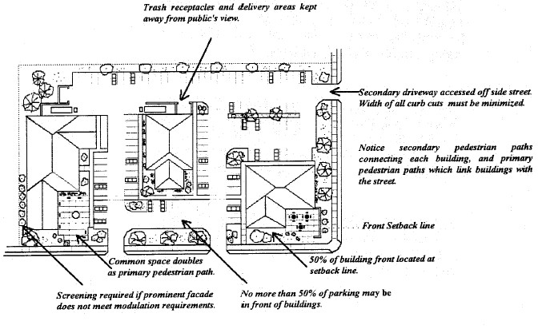

- Limit the number of curb cuts. To maximize landscaping at the street face, curb cuts for driveways shall be limited to one cut per parcel frontage or one cut per 200 feet of parcel frontage, subject to Public Works driveway separation requirements. An additional cut is allowed if the driveway is one-way. Where available, side streets or alleys should be used for additional access needs.

- Limit width of driveways to 15, 24 or 34 feet. To further maximize landscaping at the street face, one lane driveways may be no wider than 15 feet, two lane driveways may be no wider than 24 feet and three lane driveways are limited to 34 feet except that necessary flaring of the driveway may occur between the inner edge of the sidewalk and the gutter.

- Link dissimilar buildings with common site amenities. Visual continuity can be achieved between dissimilar buildings by emphasizing common elements of site design. (e.g., landscaping, screening, furnishings, light standards, decorative paving materials). Similar colors of structures can also provide visual continuity to the streetscape.

- Provide covering over walkways where appropriate. Encourage pedestrian use of walkways by providing canopies, marquees and awnings on building fronts which abut a sidewalk.

- Place no more than 50% of required parking in front of buildings. Where practical, no more than 50% of required parking may be located in front of the building. In this context, the front shall be the building side facing the street providing primary access to a site.

- Avoid parking in front of building entrance. Parking spaces in front of the main building entrance interfere with entrance visibility and access. These shall be avoided.

- Choose awning designs appropriate to building style. Awnings, canopies and marquees may not obscure architectural details of the facade.

- Ground signs should be constructed from natural materials. Grass, flowers and shrubs should be placed around the sign to provide color and visual interest.

LANDSCAPING & SCREENING

Formal landscaping provides a pleasing transition between the natural setting and the built environment and between adjacent built environments. Landscaping may not be considered adequate compensation for poor site or building design; it shall be used to enhance new development (regardless of how attractive the buildings on a site may be) and to soften the visual impacts of such urban necessities as parking lots and mechanical equipment. Natural vegetation, together with existing views of the water and land views is an integral part of the Homer setting and should be preserved on both developed and vacant parcels. Views through or framed by natural vegetation may be achieved while retaining the existing vegetation which characterizes Kachemak Bay.

- Development should be located so as to preserve, to the maximum extent possible, the best and most attractive natural features of the site. Development should avoid areas of environmental sensitivity and minimize negative impacts and alteration of natural features.
- Control vegetation to preserve existing significant views. The following standards promote retention of existing views and apply to both commercial and residential properties:

Selective thinning - Larger tree stands which, over time, have closed off significant views may be selectively thinned. Limit thinning to maintain a balance of timber and continuous canopy.

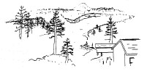
Trees make up an integral part of this view. A balance between trees and view should be retained

    - Trees within view - Allow trees to be a part of the view. Limited numbers of trees should not be considered an obstruction to a view.

    - Trimming trees. When trimming or limbing up trees to preserve views, maintain a healthy balance between the crown and trunk of the trees.

    - Tree Topping. Avoid topping or trimming which alters the natural symmetry of a tree unless necessary for safety reasons or as emergency situations dictate.

- Avoid removing significant vegetation. Complete removal of significant vegetation to create new views where views do not currently exist, or to create panoramic views out of existing limited views is not permitted.

- Provide adequate room for retained vegetation. Identify how retained trees will be protected both during and after construction.

a. Location of structures. Buildings, retaining walls, utilities and paved surfaces must be far enough away from retained trees to allow room for construction activities (including grading and excavation) and to assure a proper growth environment after construction.
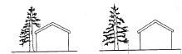
Neither the building footprint or the area of construction should encroach into the drip line of trees to be protected

b. Area of construction. In no case shall construction activities take place within the drip line of the tree (root zone) without extra precautions.

c. Tree well. Provide a tree well or other form of protection where the surrounding grade must be raised.

- Protect existing trees during construction. Significant vegetation to be retained must be protected during construction by installation of an effective system. The system must be approved by the Public Works Department, and must be in place during construction.

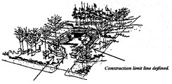
Limits of disturbance must be carefully defined and delineated. Areas of nondisturbance must be protected.

- Replace lost trees which were intended to be retained. Any tree proposed or required to be retained and which is subsequently lost or destroyed must be replaced with at least three 6-foot trees of an appropriate species.

- Choose plantings which are compatible with existing vegetation. Plantings must be of a type which will thrive amid existing vegetation without killing or overtaking it. Avoid mixing incompatible plants which require different planting environments or micro-climates. Avoid haphazard mixture of textures, colors and plant types.

- Locate vegetation to preserve significant views. Views and vistas from public rights-of-way shall be considered when determining placement of vegetation. While it is not the intent to avoid all trees in the foreground of a view, consideration should be given to the expected height of trees and how they might be located to "frame" the view.

- Retain the natural symmetry of trees. Trimming of trees shall be done in a manner that preserves the tree's natural symmetry. Topping shall be avoided unless required for health/safety reasons. Limbing-up may be appropriate if sufficient crown is retained to preserve the tree's health.

- Use shrubs or vines on blank walls. Blank walls shall include a narrow planting area with shrubs or vines giving coverage to the wall.

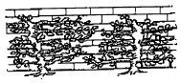
Shrubs and vines provide good coverage to walls which lack architectural interest

- Outside storage of materials and equipment and trash, if otherwise allowed, should be screened from view from adjacent streets and residential areas. Such screens should be opaque and may consist of walls, fences, landscaped berms, evergreen plantings, or any combination thereof.

- Enclosed storage of materials, equipment and trash is encouraged. The enclosure will be built to be complementary to the primary structure or landscaped or located so as to not be visible from the street.

- Elements such as, but not limited to; HVAC units, telephone boxes, fuel tanks and electrical transformers, shall be integrated into the site design through the use of landscaping, berms or fences and should be as unobtrusive as possible.

- Landscaping will be planned in such a way as to preserve views from public rights-of-way. Consideration will be given to the expected height of trees and how they might be located to frame the view.

- Landscape plants will be chosen to be compatible with existing native vegetation and to thrive in Homer’s climate.

- All disturbed lands will be revegetated within nine months or the next growing season, whichever is sooner.

17. Conform to all other landscape criteria in the Homer City Code.

Vacant Parcels in All Zones:

Limit Clearing to no more than 50% of significant vegetation and retain vegetation in all required buffers and setbacks. Clearing limitations apply to all vacant parcels with no approved Development Activity Plan, Storm Water Plan, or Zoning permit for development.

FENCES

Fences are useful for defining space, providing security, and visually enhancing outdoor settings. The degree that these qualities are considered depends on the intended purpose of the fence and where it will be located. The design of the fence may not be important if the fence is strictly for security reasons, (e.g., a mini-storage yard), but if the fence is visible to the public right-of-way, design takes on added significance. Fence height will be measured from the natural grade.

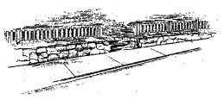
Fences must be designed to reflect traditional building materials and styles. The wood posts and rails over the rock retaining wall are appropriate.

- Choose fence materials carefully. Fences shall be constructed of wood, wrought iron, brick, stone or cinder block. Smooth-faced cinder block must have a veneer finish on the side visible to the public's view. In commercial areas or recreation centers in residential areas, coated chain link attached to wood posts and rails is permitted. Other materials which have the general appearance and visual quality of approved fence materials may be approved by the Planning Director, however, the use of plywood or composition sheeting as a fence material is not permitted.

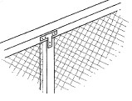
Coated chain link fencing over wood posts and rails may be acceptable in some areas.

- Limit chain link to non-visible areas. In areas not visible from any public right-of-way, waterway, or designated public space, standard chain link fencing including steel posts and rails is permitted.

- Limit height of fences. Unless otherwise required by Homer City Code, fences are limited to a height of 3 feet from the natural grade along arterial frontages and in the front yard (4 feet for open rail fences) and 6 feet in the rear yard, provided that clear vision is retained for adjacent driveways and intersections (see sight triangle provisions in Homer City Code).

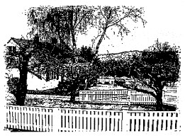
This wood picket fence serves to define the private yard while enhancing the design of the house and the streetscape. Similar types of fences are encouraged.

PARKING

Parking lots and parking structures may not visually dominate Homer's urban setting. Parking facilities shall be designed with increased emphasis on pedestrian ways and human enclosure. The following requirements are intended to mitigate the visual impacts of parking by screening parking lots from public rights-of-way and by making parking garages a secondary element in building designs.

Parking Lots:

- All off street parking and loading areas will be provided with safe and convenient access. Access locations should be designed to encourage unimpeded traffic flow, with controlled turning movements and to minimize hazards to pedestrians, bicyclists, and vehicular traffic.

- Use landscaping to screen parking lots and service areas. Parking lots and other expansive pavement areas shall include a wall, solid hedge or landscape berm at least 3 feet high (conforming to clear vision requirements at driveway entrance) parallel to the right-of-way to soften the visual impact of the lot from the street.

- Limit the number of curb cuts. To maximize landscaping at the street face, curb cuts for driveways shall be limited to one cut per parcel frontage or one cut per 200 feet of parcel frontage, subject to Public Works Standards driveway separation requirements. An additional cut is allowed if the driveway is one-way. Where available, side streets or alleys should be used for additional access needs. Collector routes, frontage roads and joint parking areas are encouraged.

- Limit width of driveways. To further maximize landscaping at the street face, one lane driveways may be no wider than 15 feet, two lane driveways may be no wider than 24-feet and three lane driveways are limited to 34 feet except that necessary flaring of the driveway may occur between the inner edge of the sidewalk and the gutter.

- Screen or enhance parking lots visible from the Sterling Highway, Lake Street, Heath Street, Main Street, or Pioneer Avenue. Parking lots designed for more than 16 cars and which are visible from these Rights-of-way shall either be partially screened or meet the following landscape standards:

  - Provide tree areas throughout parking lot. Parking lots must include areas for trees.

  - Provide color and texture to distant parking stalls. Parking surfaces which are more than 200 feet from the building they apply to and which are visible from arterials must be surfaced with colored and textured paving or other devices such as grass pavers.

- Incorporate pedestrian ways into parking- lot. Pedestrian ways, including walkways and crosswalks, shall conform to the on-site walkway requirements on page 18.

- Limit parking in front of buildings. No more than 50 percent required parking may be located in front of the building. In this context, the front shall be the building side facing the street providing primary access to a site.

- Provide trees within larger parking lots. Parking lots designed for 24 or more vehicles must include tree areas, which shall be spaced a maximum of 100 feet apart, among parking rows.

- Avoid parking in front of building entrance. Parking spaces in front of the main building entrance interfere with entrance visibility and access. These shall be avoided.

- Handicap parking. Provide handicap parking space in conformance with State of Alaska and Federal regulations.

- To minimize turning movements onto adjacent public roads, developers are encouraged to provide internal circulation systems that continue to adjacent developments. Sight design should continue internal vehicular ways in order to reduce the number of curb cuts and driveways onto the Sterling Highway.

Parking Garages:

- Recess vehicle entries in main facade. Garage doors and open vehicle entries must be recessed at least 6 feet from the front facade plane.

- Screen parking garage facade. The front parking garage facade which is visible from the street shall conform to one or a combination of the following options:

a. A landscaped screen. Screening may be trees, shrubs or wall clinging plantings on a trellis.

b. Store fronts. The parking garage may be faced with storefronts or display windows.

c. Simulated store front. The openings of the garage may be designed to reflect or simulate the window pattern and material choice of the primary structure on the site.

- Receive Commission approval for parking garages over one story or which enclose 20 or more vehicles.

OUTDOOR LIGHTING
Applicable Areas
Within Areas Zoned CBD, RR, UR, RO, GBD, SGCOL and the portion of GC1 lying south of Beluga Lake:

All uses

The primary purpose of outdoor lighting is to improve visibility and safety within outdoor spaces. However, light can also enhance a setting if the intensity and source of the light corresponds to the visual character of the surroundings.

- Keep light source hidden from public view. Except for streetlights installed in rights-of-way, all light sources, whether on public or private property, shall be hidden or conform to light standards specified herein. Light sources (e.g., light bulbs) shall not be visible except on approved decorator lights. Sources of high intensity light, whether behind a lens or not, shall not be visible to the public.

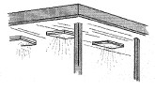
High intensity light sources may not be visible to the public Fixture designs of an industrial or utility appearance shall be avoided.

Indirect lighting keeps light source hidden from the public's view. Recessed spot lighting may supplement indirect lighting where more direct lighting is desired.

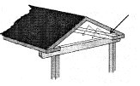

- Use downward directional lighting. All lights more than 7 feet above the ground shall be downward directional lighting.

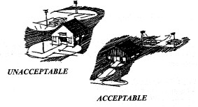
UNACCEPTABLE
ACCEPTABLE

- Avoid lighting large areas with a single source. Large areas may be lit with a number of low intensity sources close to the area requiring illumination; illumination of a large area with a remote single source of light shall be avoided.

- Avoid excessive light throw. Lighting shall not be cast beyond the premises and shall be limited to illumination of surfaces intended for pedestrians or vehicles. Illumination of landscaped areas shall be avoided unless lighting is part of the landscape design or the area is intended for recreational use.

- Choose approved outdoor light designs. The following lighting types are approved:

  - "Shoe box" style pole lamps to be approved as appropriate for district (downward directional).
  - Ornamental pole lamps - to be approved as appropriate in color and style for district.
  - Bollard lights - to be approved as appropriate in color and style for district.

    - Avoid light fixture designs which have an industrial appearance. Designs of an industrial or utility appearance shall be avoided on all fixtures visible to the public, e.g., mercury vapor lights, cobra lights, etc.
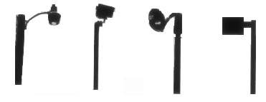

NO! NO! NO! YES!

Except for the "shoe-box" style light on the right (which is downward directional), these other lights are too industrial in their appearance and are designed for illuminating large areas with a single light source.

OUTDOOR FURNISHINGS

Encouraged in Central Business District, Marine Zoning Areas, and adjacent to Ocean Drive.

Outdoor furnishings are as important to the visual quality of the City as indoor furnishings are to a room. The choice of furnishings determine how casual or formal a setting may be and reveal a great deal about the preferences of the people the setting is designed to serve. Outdoor furnishings in public and quasi-public spaces contribute to a community image. The following requirements will assure consistency in outdoor furnishing design in public rights-of-way and are recommended guidelines for private common areas:

- Use City approved furniture designs on public rights-of-way. All furniture on rights-of-way shall be approved by the Public Works Department and the Planning Department as to its type, style, manufacturer, series, and color. Outdoor furnishing shall be of a commercial grade designed for heavy public use.

CONNECTIONS

INTENT: The intent of connections standards is to extend design consideration beyond individual parcels and emphasize (a) visual links between districts, (b) functional links between parcels, (c) transitions between dissimilar uses and (d) right-of-way and common area improvements which will create a cohesive community image.

This section will be developed further at a later date.

