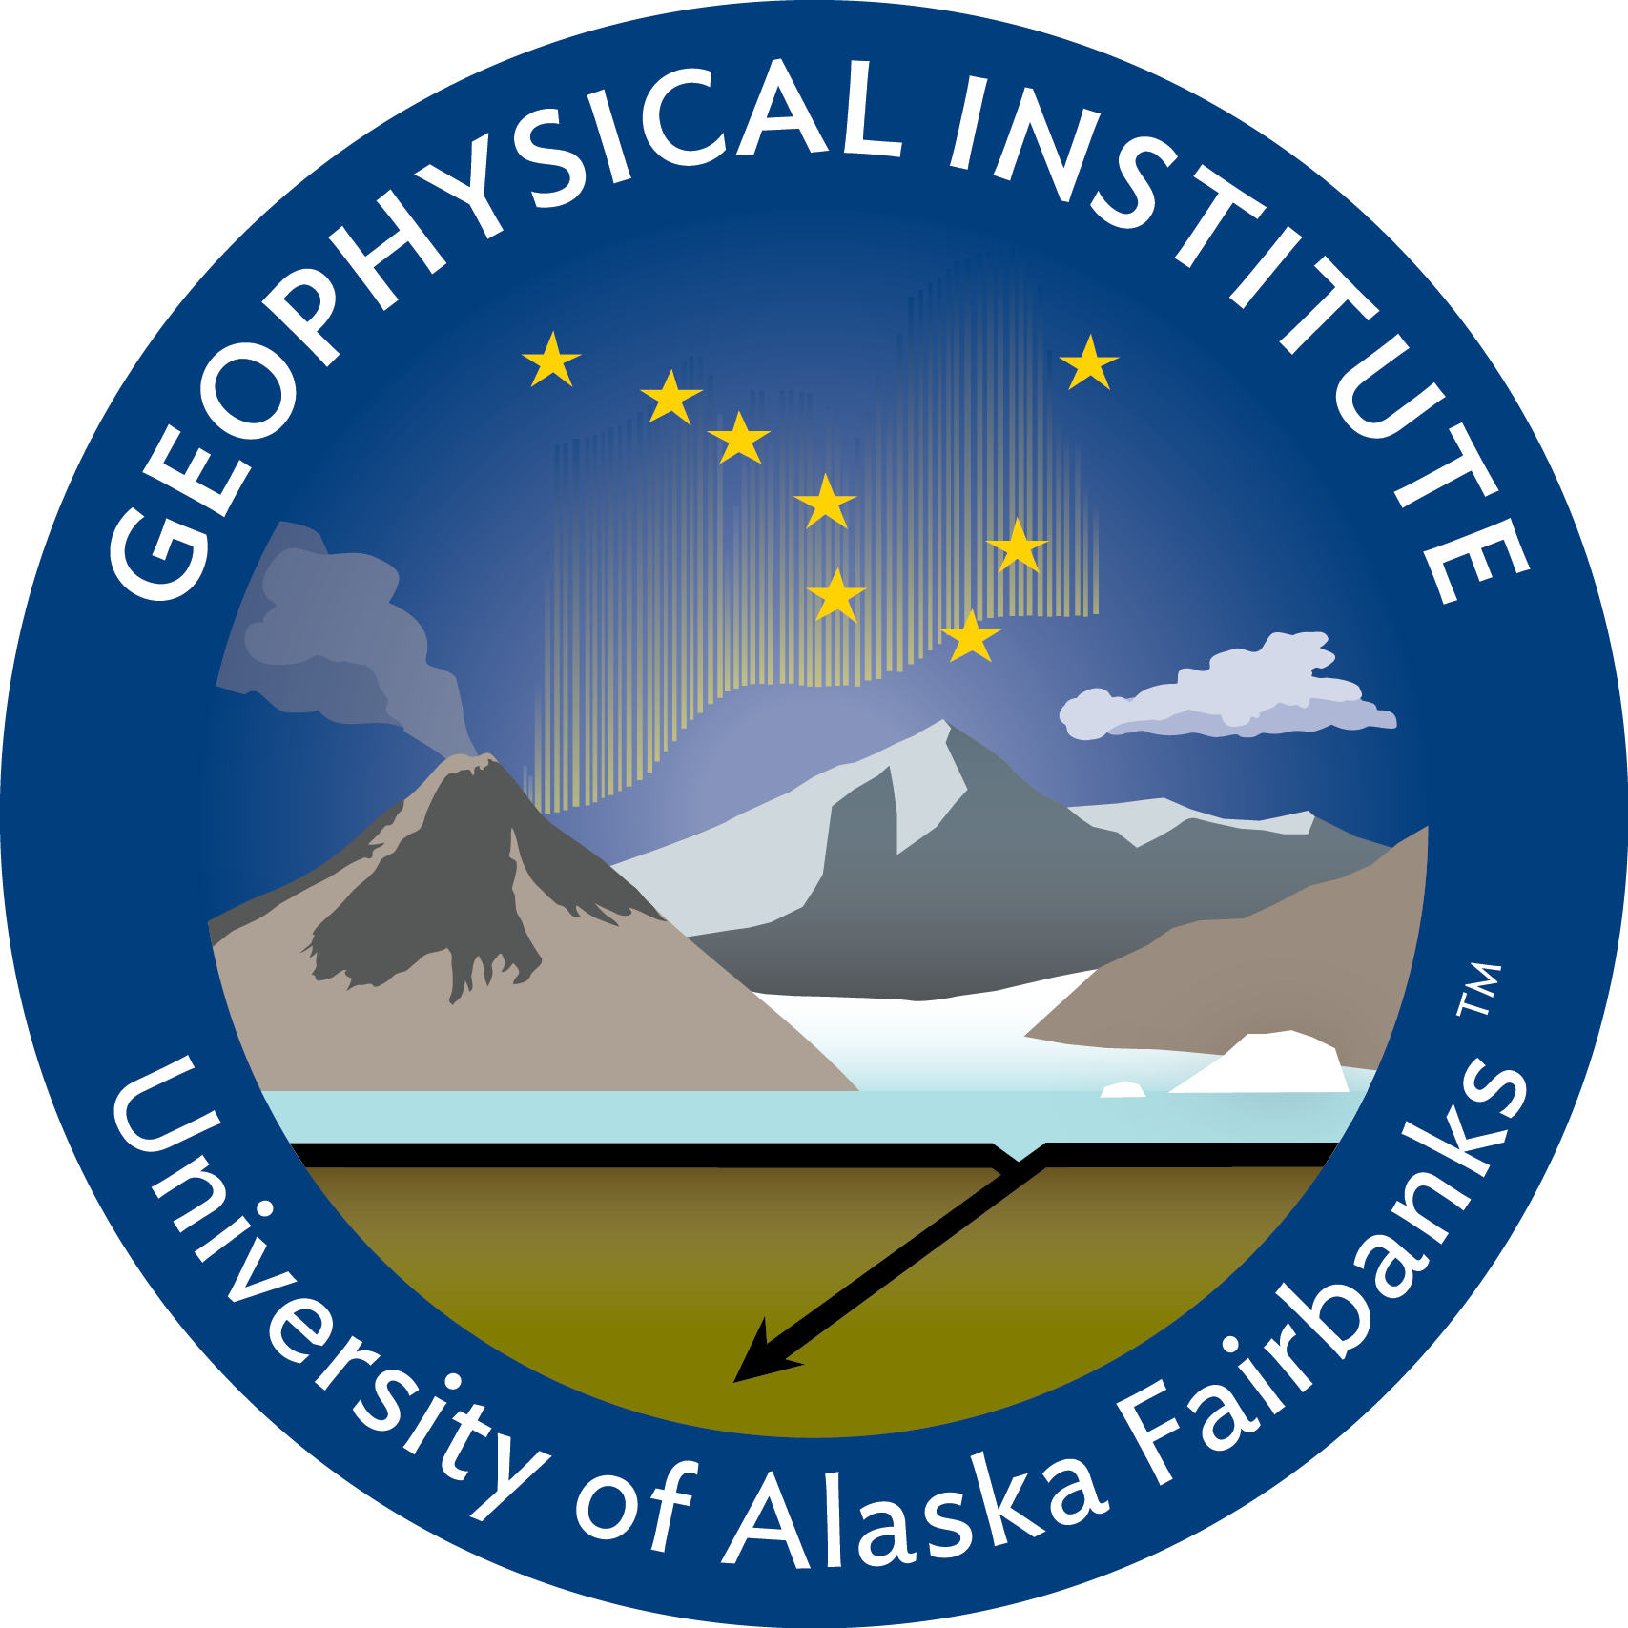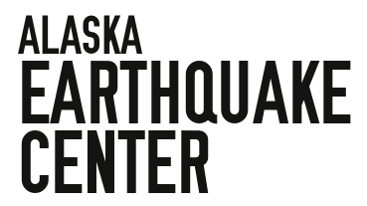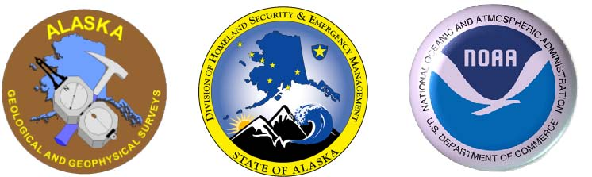

Tsunamis in Alaska and around the world

Dr. Elena Suleimani
Geophysical Institute
University of Alaska Fairbanks

The two shocking tsunami disasters of the 21st century, the 2004 in the Indian Ocean and the 2011 in Japan, have forever changed the definition of the word "tsunami". It now describes a natural hazard capable of inflicting hundreds of thousands of fatalities and reaching every coastline on earth. Alaska is the largest tsunami “producer” in the United States. Historic tsunamis that were generated in Alaska have resulted in widespread damage and loss of life around the Pacific Ocean. However, the future tsunamis “made in Alaska” can reach Alaska coastal communities within minutes of the earthquake. Saving lives and property depends on how well a community is prepared.
The updated tsunami inundation map of Homer, published in 2018, is based on the new understanding of complex tsunami sources and lessons learned from tsunami disasters of 2004 in Indonesia and 2011 in Japan. This information will help mitigate damage and loss of life from future tsunamis.

When: Tuesday, March 1st at 2 pm
Where: Homer Public Library

