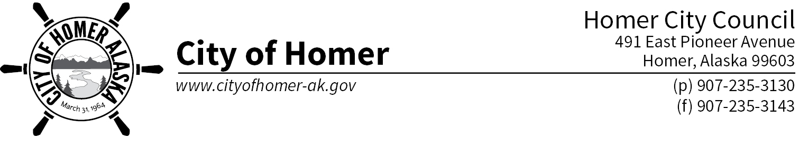

March 13, 2017

Governor Walker

Alaska State Legislature

State Capitol

Juneau, Alaska 99801

Governor Walker and Legislators of the great State of Alaska,

The Homer City Council continues to recognize our ongoing state fiscal crisis. During our recent visit to the state capitol we were encouraged by the attention being given to this serious matter by legislators. However, we found it disconcerting to find the House and Senate so far apart on the solution to the crisis. We reaffirm Homer City Council’s position submitted to you during the last legislative session via Resolution 16-017 (see attached). Producing an ongoing balanced, sustainable, and predictable budget brings confidence to Alaskan residents, investors, and the economy as a whole. We support new measures that will create a balanced and fair revenue stream to offset oil revenue losses.

The Homer City Council evaluated proposals being discussed by the legislature for balancing the state budget and has developed positions as follows:

REVENUE

* Homer City Council recognizes the need to use our largest asset – the Permanent Fund – as part of the solution and supports a percent of market value (POMV) approach that funds government while protecting the principal of the fund.
* Potential mechanisms to fill the remaining gap include an income tax, a statewide sales tax, and a variety of taxes on specific goods (such as studded tires and motor fuels). Sales taxes and taxes on specific goods may have direct impacts on municipalities such as the City of Homer.
  + Sales Tax: Over 50% of general fund revenue for the City of Homer comes from sales tax, making it an important part of how government is funded in a small town that serves as a hub community for a much greater area. Combined with the Kenai Peninsula Borough sales tax, Homer shoppers pay 7.5% sales tax. Any state-wide sales tax MUST consider the impact to local communicates and not simply add a new sales tax on top of what local municipalities charge.
  + Taxes on Specific Goods: Specific taxes goods (such as studded tires or motor fuels) hit rural areas harder than urban areas because the cost of these items is already higher. Multiple taxes on specific goods results in “death by a thousand taxes” to municipalities and local residents.

BUDGET CUTS

* The Homer City Council understands that budget cuts will continue to be considered as the state struggles to make ends meet. The community of Homer has suffered from cuts to state government during the past several years. As cuts are made, problems in our municipality, ranging from drug violence to heavy snow loads, do not go away. Below are examples of past and proposed state budget cuts that have direct or indirect impacts on the City of Homer.
  + Community Jails—the City of Homer contracts with the Department of Corrections to help fund our jail. Alaska State Troopers house prisoners at the Homer Community jail from well outside City limits. Past cuts to our contract have affected our ability to staff the jail and future cuts would be highly detrimental.
  + State Troopers—the Homer police department partners with the Alaska State Troopers on law enforcement. Reductions in coverage on the lower Kenai Peninsula affects the ability of the Homer police to do their jobs and compromises the safety of the greater Homer area.
  + Transportation—Homer is criss-crossed with state maintained roads and our community has one highway linking us to the central peninsula and Anchorage. We depend on the Alaska Department of Transportation and Public Facilities (ADOT&PF) to perform year-round maintenance on the state highway and state roads within Homer. We also have agreements with ADOT&PF for winter maintenance that would be jeopardized with further cuts the agency.
  + K-12 Education—While K-12 education is a function of the Kenai Peninsula Borough, cuts to the school district’s budget result in changes that directly affect our community’s economy.
  + University—Homer is home to the Kachemak Bay Campus (KBC) of the Kenai Peninsula College. KBC is at the heart of Homer, providing classes our community members depend on to seek undergraduate and graduate degrees, learn trades, and continue their educations. KBC is a direct positive for our economy and its loss or diminishment would leave a deep hole.
  + Community Assistance- The City of Homer no longer includes Community Assistance (formerly known as Revenue Sharing) in our annual operating budget due to its uncertain nature. However, we use the funds for capital projects in the community and appreciate that it offsets the unfunded mandate of the senior property tax exemption.

We applaud your diligence in working to resolving this crisis. As you work to balance the state budget for a sustainable future for our state, we encourage you to fully weigh the ramifications cuts and taxes have on municipalities.

Thank you again for your willingness to serve the residents of this state and your work to secure a stable future for generations to come.

Sincerely,

Homer City Council

Mayor Bryan Zak Donna Aderhold Heath Smith Tom Stroozas

Shelly Erickson David Lewis Catriona Reynolds