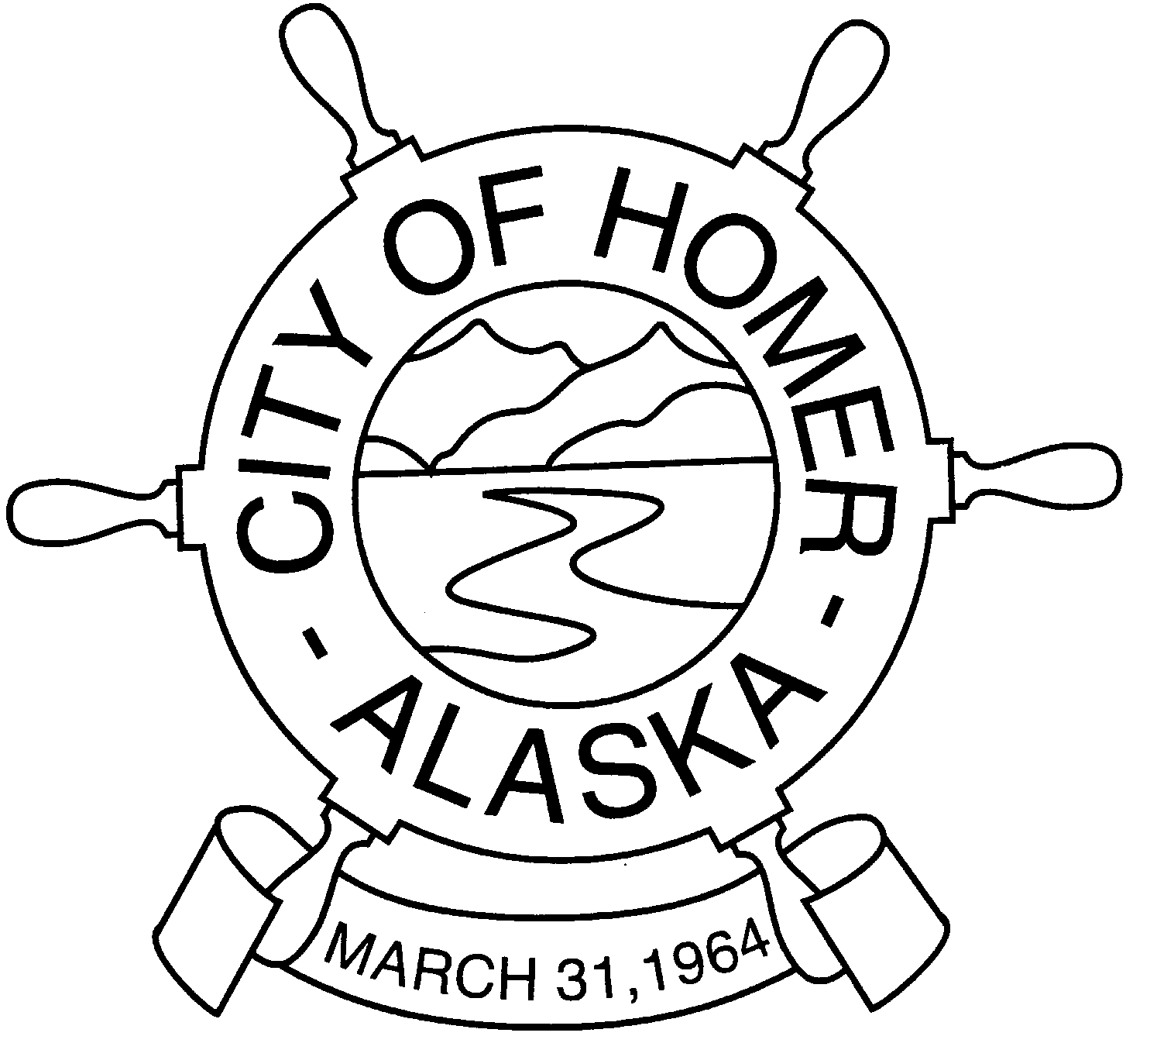
CITY OF HOMER
PUBLIC WORKS TELEPHONE (907)235-3170
3575 HEATH STREET HOMER, AK 99603 FACSIMILE (907)235-3145

MEMORANDUM 10-94

TO: Walt Wrede, City Manager

FROM: Carey Meyer, Public Works Director

DATE: June 23, 2010

RE: Projects at Public Works
__________________________________________________________________________________

Active Capital Projects Construction Value Remarks

Kachemak Dr. (Phase II) Water/Sewer Improvements $ 3,300,000 Bid/Construction
Eminent Domain Coordination $ 500,000 Final Resolution
Regulatory Permitting $ 10,000 Final Acquisition
Sanitary Sewer Rehabilitation $ 1,400,000 In Construction
Mattox Street PRV Vault Installation $ 190,000 In Construction
Soundview/Woodard Creek Culvert Replacement $ 300,000 In Design
Beluga Slough Trail Replacement $ 450,000 In Design
Pioneer Dock Corrosion Repair $ 600,000 In Design
Energy Efficiency Improvements – City Buildings $ 600,000 In Design
Seldovia Ferry Ramp Improvements $ 1,000,000 In Construction
New Water Treatment Plant Upgrade $ 5,800,000 Const. Closeout
Performance Testing $ 2,000,000 Final Stages
Eminent Domain Coordination $ 100,000 Final Resolution
Spit Parking Improvements $ 200,000 In Design
Jack Gist Park Improvements $ 55,000 In Construction
Karen Hornaday Park Improvements $ 300,000 In Planning
Animal Shelter Fencing $ 10,000 Bid/Construction
Crittenden Street Paving LID $ 200,000 Planning/Design
West Homer Elementary Trail Improvement $ 50,000 Planning/Design
Lillian Walli LID Planning $ 3,000,000 Planning

Upcoming Projects

Homer Spit Trail Improvements $ 2,000,000 Design
Deepwater Dock Improvements $ 30,000,000 Design
City Hall Renovations $ 1,900,000 Design
Old Water Treatment Plant Demo/Rehab $ 320,000 Design
Seawall Phase II $ 2,000,000 Permitting
Main Street/Sterling Highway Intersection Improvements $ 2,000,000 Planning/Design

